Head and Neck Phantom

Guidelines for Planning and Irradiating the IMRT Phantom.
Revised July 2025

GENERAL INFORMATION:
Each institution may keep the phantom for a period of time no more than 2 weeks. During this two-week period, the institution will image, plan, and treat the phantom and return. Thank you for your cooperation.

The phantom has one insert. The phantom contains TLD at 8 locations and perpendicular sheets of film. Four TLD are located in the primary PTV, and two each in the secondary PTV and in the organ at risk (spinal cord).
If you have any questions, please contact the appropriate person.

Nadia Hernandez (713)-745-8989 Nhernand@mdanderson.org
Andrea Molineu (713) 745-8989 amolineu@mdanderson.org

DOSIMETRY INFORMATION TO BE SUBMITTED:

The following information is to be submitted when returning the phantom:
- Original hard copy isodose distribution in coronal and sagittal planes through target center.
- Treatment plan report or summary.
- Screen shots showing the contour of the TLD (similar to the figure below).
- Data to be upload to OneDrive - A folder has been created with your institution name on OneDrive and it will be shared with you via email. Please upload the digital treatment planning data in the DICOM format which include all CT slices with 3D composite Dose, RTStructure and RTPlan. Please compress the file before upload to avoid the file corrupt during the process.
- Please inform phantom team by email, Nhernand@mdanderson.org, when you finished the upload.

Please note, if unable to do the above please send a CD with all the requested data with the phantom.

The Phantom should be imaged, planned, and irradiated as if it were an actual protocol patient, incorporating all of your customary quality assurance checks.

DOSE PRESCRIPTION:
The doses to be delivered to the phantom are a factor of 10 less than the protocol dose specifications, namely:
- Primary PTV.
  - 6.6 Gy to at least 95% of the PTV and
  - < 1% of the PTV receives < 93% of the prescribed dose.
- Secondary PTV (Node or Salivary gland):
  - 5.4 Gy to at least 95% of the PTV and
  - < 1% of the PTV receives < 93% of the prescribed dose.
- Organ at risk:
  - < 4.5 Gy, maximum dose.
- Normal tissue:
  - ≤ 110% of the prescribed dose (6.6 Gy).

IRRADIATING THE PHANTOM

- Material included in box:
Head Phantom, with 1 or 2 TLD capsules taped to each ear.
Phantom insert (already place on head phantom)
Envelope with background film (hidden from your view; please don’t try to find it)
Pillbox to accept TLD from phantom ears.
FedEx repaid return label
- The adjustment screws in the back of the phantom base should make the phantom adaptable to most head holders.
Procedures:
- This phantom has only one insert. The same insert is used for both imaging and for treatment.
- Make sure that there is 2TLD capsules taped into each ear. If they have come out, please tape them back in. They will remain in for the imaging process, then be removed so as to determine background for the Therapy TLD in the insert.
- CT Scan the phantom as you would a patient. You may wish to scan with 1.5 mm slices especially near the center to better identify the TLD capsules. Rotate the adjustment screws to support and position the phantom.
- Remove the ear TLD after imaging and alignment (KV, CBCT…) are complete and before treatment begins. Place in a pillbox labeled “ear TLD”.
- Segment the phantom images contouring the skin, primary and secondary planning target volumes (PTVs) and the organ at risk (OAR) analog (posterior to the primary target volume crescent) and all 8 TLD volumes. TLD are in the locations shown in the diagram superior and inferior to the axial film.

Please use the following names for your contours:
PTV_66 for the 1° PTV
PTV_54 for the 2° PTV
CORD for the OAR
66_Sant_TLD and 66_Iant_TLD for the superior and inferior anterior TLDs in the 1° PTV
66_Spost_TLD and 66_Ipost_TLD for the superior and inferior posterior TLDs in the 1° PTV
SCORD_TLD and ICORD_TLD for the superior and inferior TLDs in the OAR
S54_TLD and I54_TLD for the superior and inferior TLDs in the 2° PTV
- The dimensions of the TLD volume are approximately 10 mm long by 2 mm diameter
- The outside dimensions of the TLD capsules are 15 mm long by 4 mm diameter, the TLD axis lies in a sagittal plane. (Both the capsules and the TLD should be visible on CT image)
- Plan the treatment as specified in the DOSE PRESCRIPTION above.
- Perform your customary QA of the IMRT plan prior to irradiating the phantom.
- Treat the phantom with the developed plan as you would an actual patient. .
- Make sure that the "ear TLD" pillbox is on the box.
- Include the dosimetry data discussed above. Complete the attached forms. Isodose lines should include at least the following: 6.6, 5.4, 5, 4.5, 4, 3.5 Gy.
- Return the complete package using FedEx prepaid label provided in the case.

Head and Neck Phantom- Institution Information
Institution:
Address:

Treatment Unit used for irradiation:
Manufacturer: Model (Head model if Elekta):
Serial number: _______________________
Photon Energy Nom __________(MV) Is this a: FFF beam _______ or SRS beam ______
Person performing irradiation:
Email: _______________________________________________________________________
Irradiation date: ________________

IMRT Technique for this irradiation:
___ Segmental (step and shoot) MLC ___ Dynamic MLC ___ Tomotherapy
___ VMAT Other: _______________________________

Intensity Modulation Device for this irradiation:
___ Multileaf Collimator Model: ___________________________________

TPS information for this irradiation
Manufacturer __________________ Model_____________ Algorithm_________________
Version number ________________

Contact Information for this irradiation
Physicist to receive report:
Person to call in case of questions:
Phone Number:______________________ Email address: _______________________________
Please enclose original copies of your treatment plans. Include the slices where the films are and scaling factors.
Indicate the dose delivered to the TLD as determined by your treatment planning computer
TLD | Mean Dose(Gy) | Min Dose(Gy) | Max Dose(Gy)
Ant Primary PTV superior
Ant Primary PTV inferior
Post Primary PTV superior
Post Primary PTV inferior
Secondary PTV superior
Secondary PTV inferior
Organ at risk superior (S cord)
Organ at risk inferior (I cord)

Results of IMRT QA (please attach copies of measurement data): _________________________
Did you adjust the MU based on these results?___________ If so, how much?_______________
Did you irradiate the phantom in service or clinical mode? ______________________________
Did you use your record and verify system? __________________________________________
Attach copies of the treatment plan including a plan in the axial and sagittal film planes
Comments:
______________________________________________________________________________
______________________________________________________________________________
______________________________________________________________________________

For Office Use Only | Batch TLD  20 | Phantom ID # | Code | Date Sent |  | Date Rec'd
 | EBT4 LOT # 03042502 |  |  |  | NH

This is a cross sectional view of the insert. The TLD are located superior and inferior to the axial film.
Anterior
Left
Posterior
Right
Organ at risk
TLD
Anterior TLD
PosteriorTLD

Axial Film Plane
TLD
Primary PTV

Sagittal Film Plane

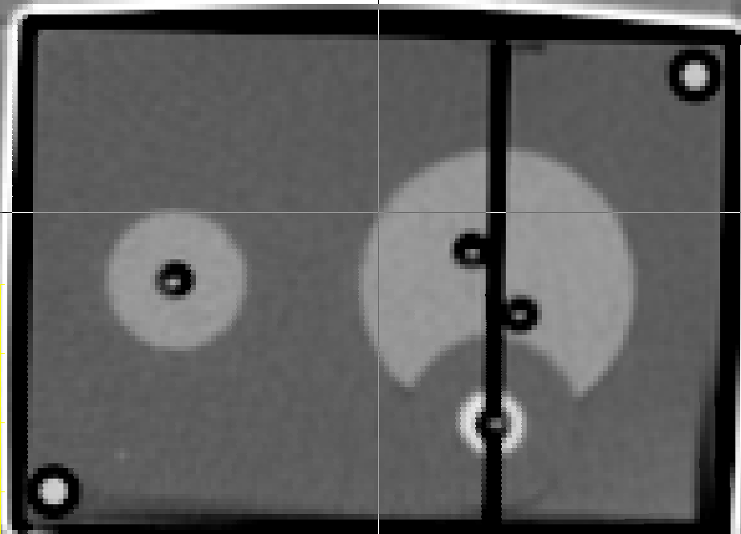
Secondary PTV

Notes:

For H&N # 2 and #4 The Primary PTV is on the right side

You need to deliver 6.6 Gy to the 1ºPTV (in 1 or more fraction). Total dose to the 1⁰PTV 6.6 Gy.

Please do not write on the phantom, you are welcome to use masking tape to aid on the localization, make sure to remove the tape after irradiation.

There is 4 TLDs on the ears, 2 on each ear, please don’t forget to remove all of them.

Thanks

Phantom team

